**Sunday, October 6, 2024**

**Worship 11:00am – Pentecost 20**

**Welcome**

**Songs**

**Prayer of the Day**

**Children’s Message: Mark 12:38-44** *Whirl Kids*

**Announcements**

**Sacred Break/Fellowship Time**

**Profession of Faith – The Jesus Creed**

**Prayers of the People**

**Offering & Worship Song**

**Offering Prayer**

**Scripture: James 4:1-10** *The Message*

**Message**

**Song of the Day – Cherish**

**Lord’s Prayer**

**Blessing**

* **Worship services are intended to welcome children and their families into time with God. Children are welcome to stay with parents for worship.**
* **Power Zone (Sunday School) – PowerZone is in portable A.**

**October’s PowerZone has been sponsored by Betty & Gordon McRae. Thanks for inspiring young kids.**



**October’s**

**bulletin has been sponsored by**

**Gordon & Betty McRae. Thank you for a well done bulletin.**



**October’s music has been sponsored by**

**Betty & Gordon McRae. Thank you for great music.**



**October’s hospitality has been sponsored by Gordon & Betty McRae. Giving thanks for great things happening in the church.**



**#MakingFaithMatter**

**This year’s AGM will be on Sunday, October 27th.**

**Please plan on attending as we discuss the future for First Lutheran Church**



The Men's Lunch is this week.



Lunch is at noon on Thursday,

October 10th at Imperial Tap

(4th ave & 4th street SW)

Please text Wayne at

403-991-3506 and let him know you are attending so he can

reserve a table.

It is time to renew your **Canada Lutheran** **Magazine**. Subscriptions must be received by October 31st if you want to renew or start receiving this terrific magazine. We have a discounted rate of $18.11 for a year. Make cheques payable to First Lutheran Church. For more information please see Liz.

**It’s concert time!**

**Yvonne is throwing a concert to raise money for Lutheran Campus Ministry and will be playing**

**Jesus Radio Superstar Songs.**

**Join Yvonne and her team on Saturday October 26th from**

**7:00 – 8:30.**



**Donations will be gratefully accepted for this event and tax receipts issued. Make donations payable to First Lutheran and designate your offering to LCM**

**Join us Thursday,**

**October 17th for our Soup Social at noon in the Sanctuary.**

**Please sign up or R.S.V.P. to Kelly @ 403-242-4544 by Tuesday, October 15th to ensure that enough soup is made.**

**Join us, Sunday,**

**October 20th, for a unique**

**Feast & Fellowship**

**in the gym after service.**

**People from the Turkish Community will be providing Turkish dishes for us to try.**

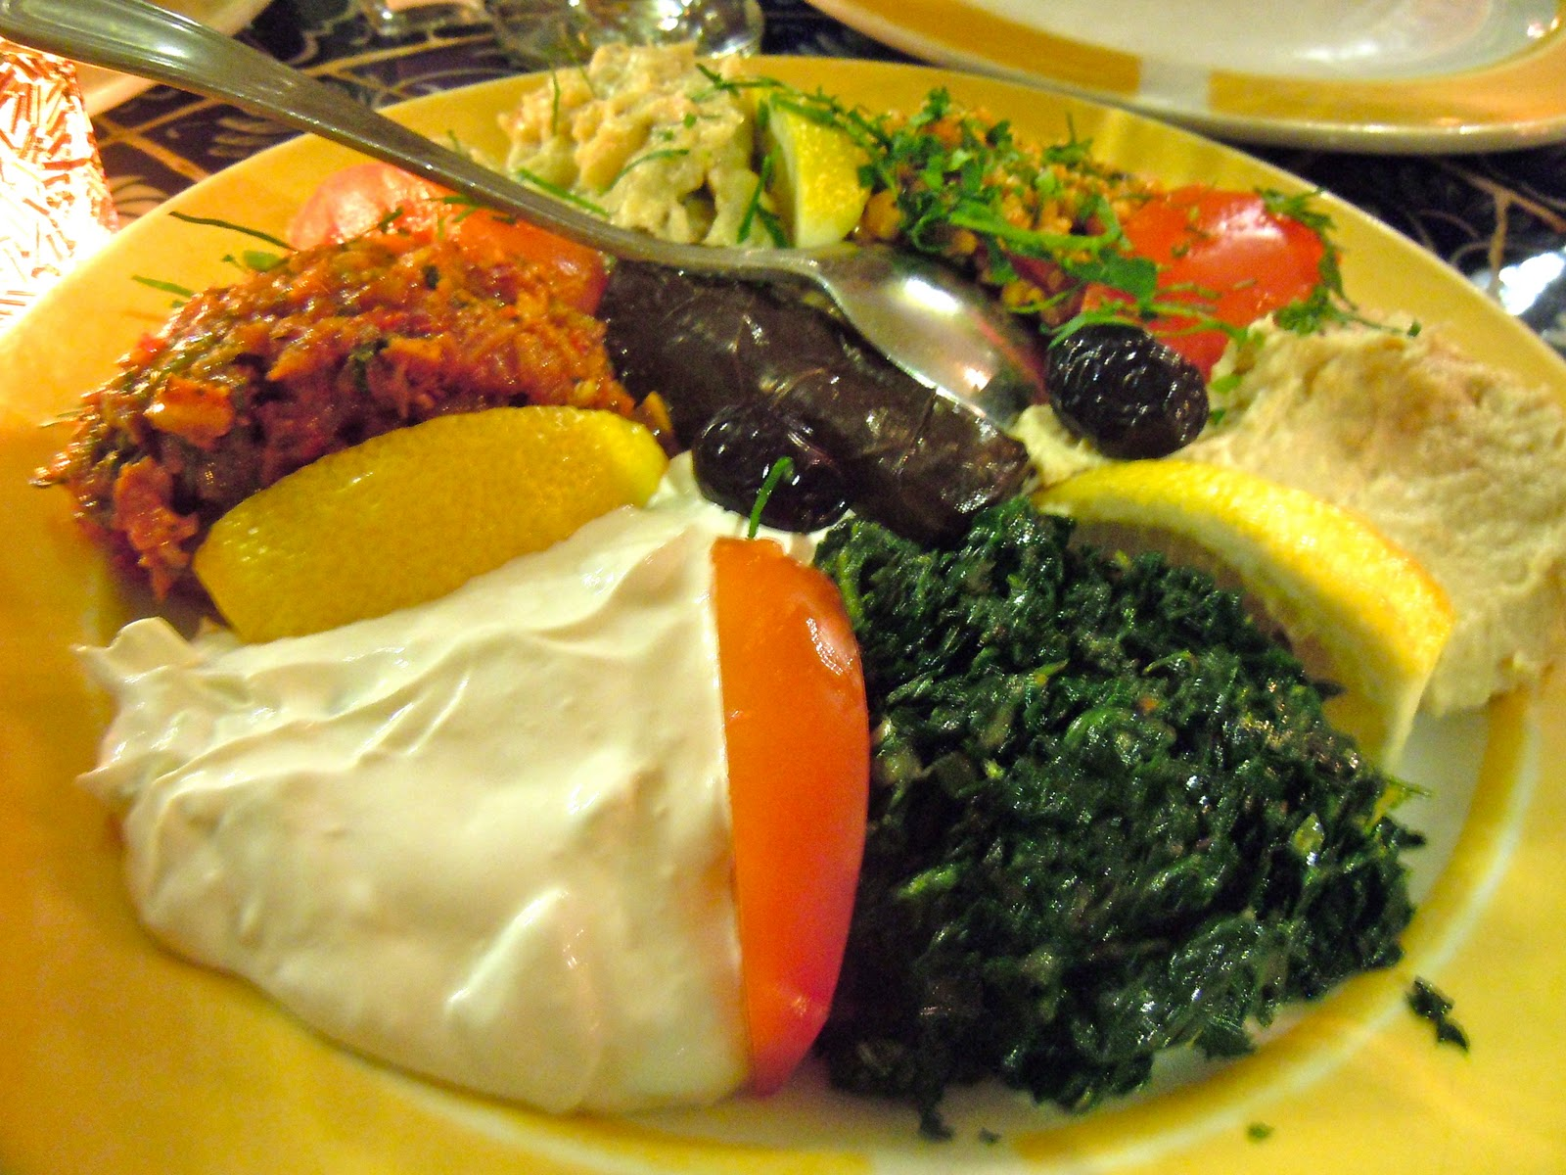

**Please try to bring your favourite dessert item and take an opportunity try a Turkish dish.**

It is time to renew your **Canada Lutheran** **Magazine**. Subscriptions must be received by October 31st if you want to renew or start receiving this terrific magazine. We have a discounted rate of $18.11 for a year. Make cheques payable to First Lutheran Church. For more information please see Liz.

**We are going to be having a bake sale during the intermission at the concert with proceeds going to Lutheran Campus Ministry.**

**Please bring a baked good wrapped and ready to sell on October 26th.**



**First Lutheran’s Vision Statement.**

**First Lutheran Church is a dynamic**

**Christian community that is making faith matter**

**in a constantly changing world.**

Facebook.com/FirstLutheranChurchCalgary

@FLCCalgary

Youtube.com/FirstLuthCalgary

FLCCalgary

**Visit us online at www.makingfaithmatter.ca**

**Want to contact us?**

**Office Hours: Monday – Wednesday, 10am-3pm**

**Office Phone 403-242-4544**

**Phil –** Pastor: Local 206 Cell number: 403-813-6797

[**phil@makingfaithmatter.ca**](mailto:phil@makingfaithmatter.ca)

**Kelly** – Financial Assistant & Property Manager:Local 207

Christmas Eve Candlelight Services

December 24th

at 3, 5 and 7pm.

Communion will

be served at all

three services.

All are welcome.

[**kelly@makingfaithmatter.ca**](mailto:kelly@makingfaithmatter.ca)

**Yvonne –** Worship Director: Local 202

[**worship@makingfaithmatter.ca**](mailto:worship@makingfaithmatter.ca)

**Council –** Council Members

[**council@makingfaithmatter.ca**](mailto:council@makingfaithmatter.ca)

**Prayer –** SundayPrayer & Prayer Chain

[**prayer@makingfaithmatter.ca**](mailto:prayer@makingfaithmatter.ca)

**First Lutheran Church**

**7102 – 14th Avenue SW**

**Calgary, Alberta T3H 4G7**

**Tel: 403-242-4544**

[**www.makingfaithmatter.ca**](http://www.makingfaithmatter.ca)