**Sunday, October 27, 2024**

**Worship 11:00am – Reformation Sunday**

**Welcome**

**Songs**

**Prayer of the Day**

**Children’s Message**

**Announcements**

**Call to Order**

**Business**

**Reports**

**Scripture: James 2:14-26**

**Message**

**Possibilities Conversations**

**Offering & Worship Song**

**Offering Prayer**

**Business**

**Lord’s Prayer**

**Sending Song**

**Adjournment**

**Blessing**

* **Worship services are intended to welcome children and their families into time with God. Children are welcome to stay with parents for worship.**
* **Power Zone (Sunday School) – PowerZone is in portable A**

**October’s PowerZone has been sponsored by Betty & Gordon McRae. Thanks for inspiring young kids.**



**October’s**

**bulletin has been sponsored by**

**Gordon & Betty McRae. Thank you for a well done bulletin.**



**October’s music has been sponsored by**

**Betty & Gordon McRae. Thank you for great music.**



**October’s hospitality has been sponsored by Gordon & Betty McRae. Giving thanks for great things happening in the church.**



**#MakingFaithMatter**

**Our AGM is today**

**Sunday, October 27th.**



**Next Sunday, November 3rd, Daylight Saving Time ends and it will be time to “fall back”. Turn your clocks back an hour.**



The Men's Lunch is next week!



Lunch is noon on Thursday,

November 7th at Imperial Tap

(4th ave & 4th street SW)

Please text Wayne at

403-991-3506 and let him know you are attending so he can

reserve a table.

It is time to renew your **Canada Lutheran** **Magazine**. Subscriptions must be received by October 31st if you want to renew or start receiving this terrific magazine. We have a discounted rate of $18.11 for a year. Make cheques payable to First Lutheran Church. For more information please see Liz.

**Ladies Coffee Connect is next**

**Thursday, November 7nth**

**9:30 – 11:00**



**Pub Night is today Sunday, October 27th.**

**Join us for some fellowship time**

**from 5:30 – 7:00 at the Dorset**

**37th street & 17th avenue.**



**Join us Thursday,**

**November 14th, for our**

**Soup Social at noon in the Sanctuary.**

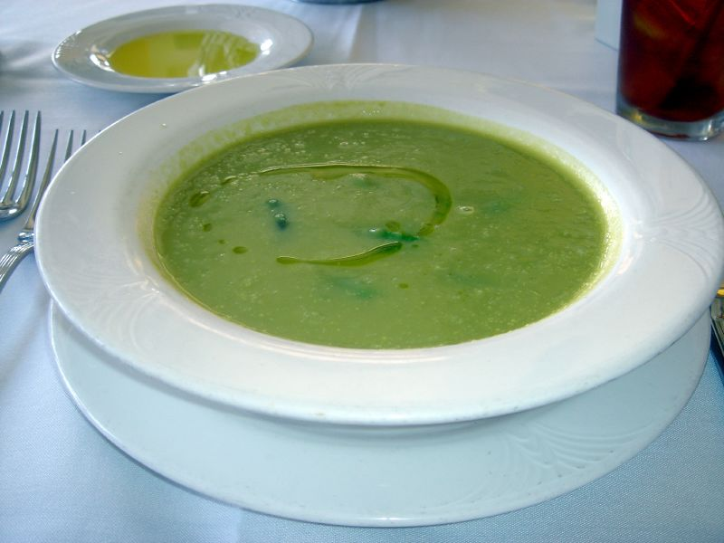

**Please sign up or R.S.V.P. to Kelly @ 403-242-4544 by Sunday, November 3rd to ensure that enough soup is made.**

**Did you know that there are many ways you can give your tithe at**

**First Lutheran Church?**

**At service you can give your offering by cheque, cash or credit card.**

**You can also**

**e-Transfer your donation to** [**kelly@makingfaithmatter.ca**](mailto:kelly@makingfaithmatter.ca)

**Donations can also be done thru PAR (preauthorized remittance)**

**or by donating stock to**

**First Lutheran Church.**

**If you have any questions about donating please talk to Kelly.**



It is time to renew your **Canada Lutheran** **Magazine**. Subscriptions must be received by October 31st if you want to renew or start receiving this terrific magazine. We have a discounted rate of $18.11 for a year. Make cheques payable to First Lutheran Church. For more information please see Liz.

**Bottle and can collection is ongoing.**

**Please drop your bottles off by the shed closest to the garbage bin.**

**Your support is appreciated!**



**First Lutheran’s Vision Statement.**

**First Lutheran Church is a dynamic**

**Christian community that is making faith matter**

**in a constantly changing world.**

Facebook.com/FirstLutheranChurchCalgary

@FLCCalgary

Youtube.com/FirstLuthCalgary

FLCCalgary

**Visit us online at www.makingfaithmatter.ca**

**Want to contact us?**

**Office Hours: Monday – Wednesday, 10am-3pm**

**Office Phone 403-242-4544**

**Phil –** Pastor: Local 206 Cell number: 403-813-6797

[**phil@makingfaithmatter.ca**](mailto:phil@makingfaithmatter.ca)

**Kelly** – Financial Assistant & Property Manager:Local 207

Christmas Eve Candlelight Services

December 24th

at 3, 5 and 7pm.

Communion will

be served at all

three services.

All are welcome.

[**kelly@makingfaithmatter.ca**](mailto:kelly@makingfaithmatter.ca)

**Yvonne –** Worship Director: Local 202

[**worship@makingfaithmatter.ca**](mailto:worship@makingfaithmatter.ca)

**Council –** Council Members

[**council@makingfaithmatter.ca**](mailto:council@makingfaithmatter.ca)

**Prayer –** SundayPrayer & Prayer Chain

[**prayer@makingfaithmatter.ca**](mailto:prayer@makingfaithmatter.ca)

**First Lutheran Church**

**7102 – 14th Avenue SW**

**Calgary, Alberta T3H 4G7**

**Tel: 403-242-4544**

[**www.makingfaithmatter.ca**](http://www.makingfaithmatter.ca)