**Sunday, March 23, 2025**

**Worship 11:00am – Lent 3**

*All are welcome!*

*There is a learning experience for children which begins with the* **Children’s Message** *and continues in one of the classrooms (Portable A)***.** *We call that experience,* **PowerZone.**

*The children return during the Song of the Day.*

*{BTW, you are invited to bring your coffee into the chapel.}*

**Welcome**

**Call to Worship**

**Confession and Forgiveness**

**Songs**

**Prayer of the Day**

**Children’s Message**

**Announcements**

**Sacred Break**

*An extended time of Fellowship.*

**Affirmation of Faith**

**Offering & Prayer Time**

*You are invited to add your prayer to the Prayer Wall.*

**Prayer for Illumination**

**The Story of Moses**

[*Deuteronomy 30:15-20]*

**Message**

**Song of the Day**

**Lord’s Prayer**

**Sending Song**

**Blessing**

**MakingFaithMatter**

**Join us after service April 6th in the gym for a potluck lunch.**



**We will need volunteers to help with this event. Sign-up sheet are on the table in the lobby.**

**Join Pastor Phil Wednesday evenings during the Lent season for a Holden Evening Prayer service. The service is from 7:00pm – 7:30pm**

**Wednesday March 12thand continues until April 9th**



**Consider sponsoring the bulletin, hospitality, music or PowerZone for a special occasion or**

**“just because”.**

**Sponsor sheets are on the bulletin board in the lobby under the clock.**



***Upcoming Events at First Lutheran Church***

**March 25 - Digging Into the Word. 10:00 – 11:30 @ the church office**

**March 25 – Council meeting 7:00 @ the church office**

**March 26 – Holden Evening Prayer 7:00pm in the Sanctuary**

**April 2 – Holden Evening Prayer 7:00pm in the Sanctuary**

**April 2 – Confirmation class for youth. 6:00 – 8:00 @ church office & Sanctuary**

**April 8– Digging Into the Word. 10:00 – 11:30 @ the church office**

**April 9 – Confirmation class for youth. 6:00 – 8:00 @ church office & Sanctuary**

**April 9 – Holden Evening Prayer 7:00pm in the Sanctuary**

**March’s PowerZone has been sponsored by Ken & Sharon West**





**March’s hospitality has been sponsored by Sharon & Ken West**



**March’s**

**bulletin has been sponsored Angela & Jim in celebration of Alexandra’s baptism last month.**



**March’s music has been sponsored**

**Tim & Kelly in celebration of Yvonne & Kelly’s birthday.**



**#**

**First Lutheran’s Vision Statement.**

**First Lutheran Church is a dynamic**

**Christian community that is making faith matter**

**in a constantly changing world.**

Facebook.com/FirstLutheranChurchCalgary

@FLCCalgary

Youtube.com/FirstLuthCalgary

FLCCalgary

**Visit us online at www.makingfaithmatter.ca**

**Want to contact us?**

**Office Hours: Monday – Wednesday, 10am-3pm**

**Office Phone 403-242-4544**

**Phil –** Pastor: Local 206 Cell number: 403-813-6797

[**phil@makingfaithmatter.ca**](mailto:phil@makingfaithmatter.ca)

**Kelly** – Financial Assistant & Property Manager:Local 207

Christmas Eve Candlelight Services

December 24th

at 3, 5 and 7pm.

Communion will

be served at all

three services.

All are welcome.

[**kelly@makingfaithmatter.ca**](mailto:kelly@makingfaithmatter.ca)

Worship for the Third Sunday in Lent

March 23, 2025

First Lutheran Church

*The Story of Moses*

**Yvonne –** Worship Director: Local 202

[**worship@makingfaithmatter.ca**](mailto:worship@makingfaithmatter.ca)

**Council –** Council Members

[**council@makingfaithmatter.ca**](mailto:council@makingfaithmatter.ca)

**Prayer –** SundayPrayer & Prayer Chain

[**prayer@makingfaithmatter.ca**](mailto:prayer@makingfaithmatter.ca)

**First Lutheran Church**

**7102 – 14th Avenue SW**

**Calgary, Alberta T3H 4G7**

**Tel: 403-242-4544**

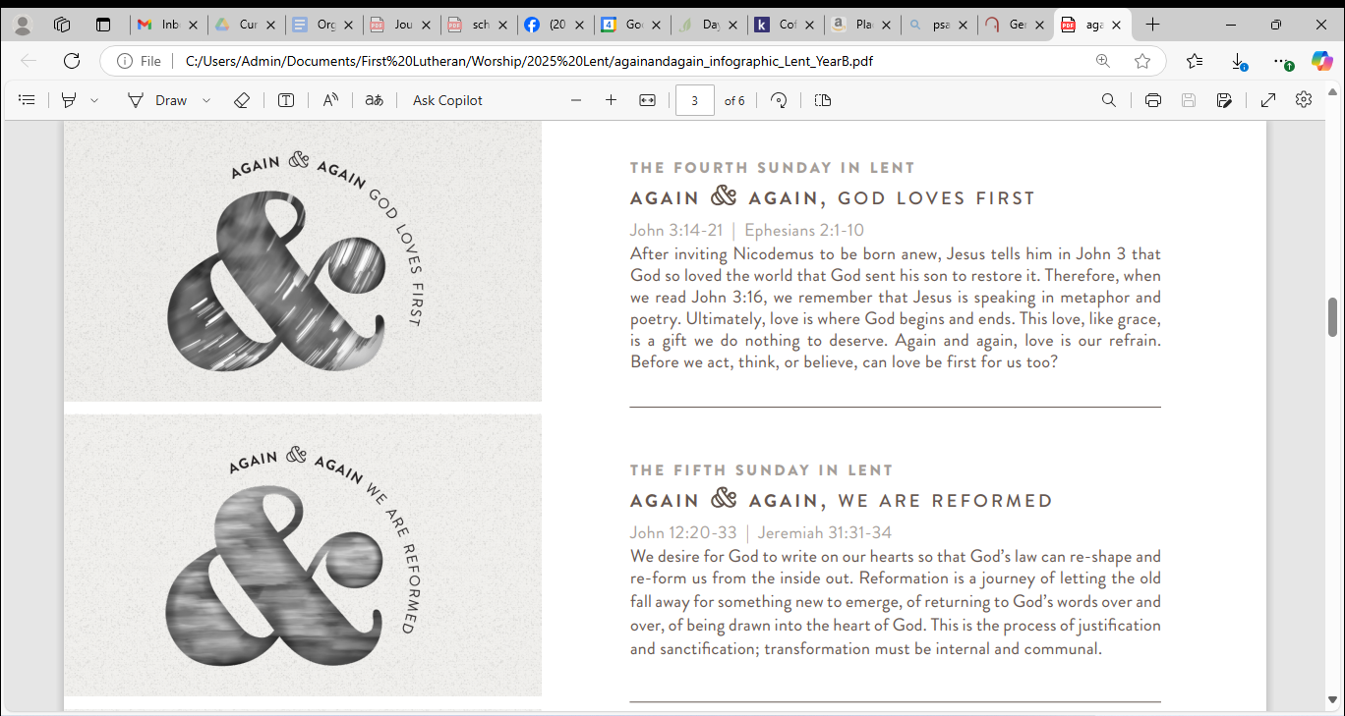**Journeying with God**