**Sunday, June 2, 2024**

**Worship 11:00am – Pentecost 2**

**Welcome**

**Songs**

**Prayer of the Day**

**Children’s Message**

**Children’s Scripture: 2Corinthians 4:5-12**

**Prayers of the People**

**Announcements**

**Sacred Break/Fellowship Time**

**Offering & Worship Song**

**Offering Prayer**

**Scripture: Philippians 1:1-11** *NRSV*

**Reflection/Message**

**Song of the Day**

**Affirmation of Baptism - Confirmation**

**Holy Communion**

**Blessing**

* **Worship services are intended to welcome children and their families into time with God. Children are welcome to stay with parents for worship.**
* **Power Zone (Sunday School) – is on summer break and will resume September 8th**

**June’s music has been sponsored by Brent in celebration of Elizabeth’s birthday**



**June’s**

**bulletin has been sponsored by Antje & Rainer**

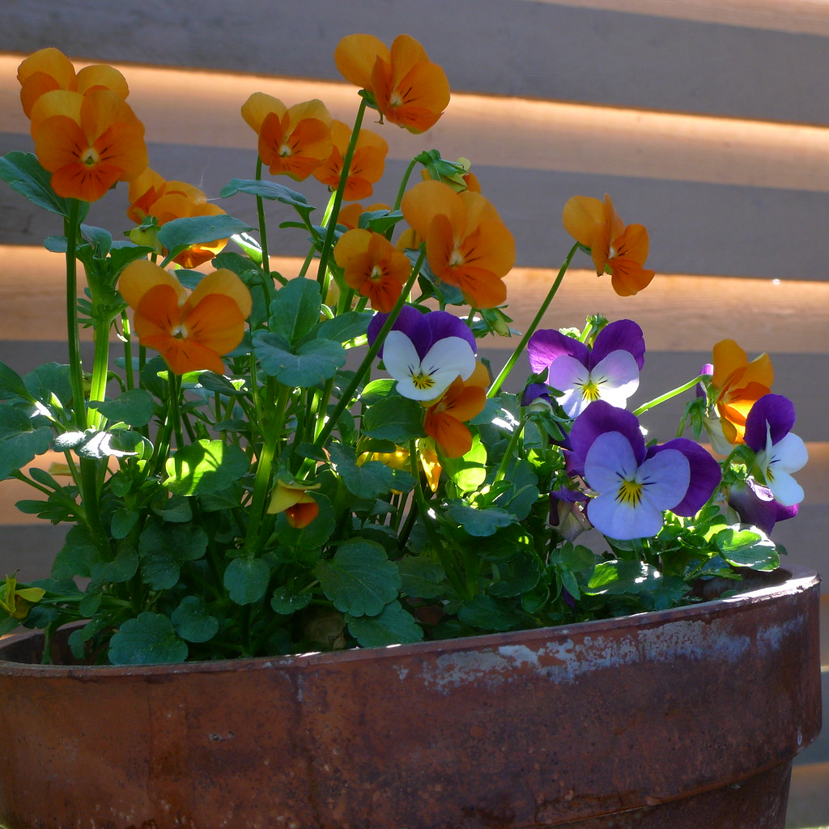

**June’s hospitality has been sponsored by Marlene & Dale in honour of confirmation class**



**June’s PowerZone has been sponsored by Antje & Rainer**



**#MakingFaithMatter**

**Join us next Sunday as we celebrate the confirmation of Veronica and Reagan**



**Today we will be will be celebrating the confirmation of Kalina, Jayde, Grace, Bella, Isaac, Marissa and Jayme.**

**Please join us after service for a piece of confirmation cake in the lobby.**



It is time to renew your **Canada Lutheran** **Magazine**. Subscriptions must be received by October 31st if you want to renew or start receiving this terrific magazine. We have a discounted rate of $18.11 for a year. Make cheques payable to First Lutheran Church. For more information please see Liz.

**Join us next Sunday,**

**June 9th, for**

**Feast & Fellowship**

**in the gym after service.**



It is time to renew your **Canada Lutheran** **Magazine**. Subscriptions must be received by October 31st if you want to renew or start receiving this terrific magazine. We have a discounted rate of $18.11 for a year. Make cheques payable to First Lutheran Church. For more information please see Liz.

**Ladies Coffee Connect is this Friday,**

**June 7th from 9:30 – 11:00**



**Did you know that there are many ways you can give your tithe at**

**First Lutheran Church?**

**At service you can give your offering by cheque, cash or credit card.**

**You can also**

**e-Transfer your donation to** [**kelly@makingfaithmatter.ca**](mailto:kelly@makingfaithmatter.ca)

**Donations can also be done thru PAR (preauthorized remittance)**

**or by donating stock to**

**First Lutheran Church.**

**If you have any questions about donating please talk to Kelly.**



**Consider sponsoring the bulletin, hospitality, music or PowerZone for a special occasion or “just because”.**



**Sponsor sheets are on the bulletin board in the lobby under the clock.**

**First Lutheran’s Vision Statement.**

**First Lutheran Church is a dynamic**

**Christian community that is making faith matter**

**in a constantly changing world.**

Facebook.com/FirstLutheranChurchCalgary

@FLCCalgary

Youtube.com/FirstLuthCalgary

FLCCalgary

**Visit us online at www.makingfaithmatter.ca**

**Want to contact us?**

**Office Hours: Monday – Wednesday, 10am-3pm**

**Office Phone 403-242-4544**

**Phil –** Pastor: Local 206 Cell number: 403-813-6797

[**phil@makingfaithmatter.ca**](mailto:phil@makingfaithmatter.ca)

**Kelly** – Financial Assistant & Property Manager:Local 207

Christmas Eve Candlelight Services

December 24th

at 3, 5 and 7pm.

Communion will

be served at all

three services.

All are welcome.

[**kelly@makingfaithmatter.ca**](mailto:kelly@makingfaithmatter.ca)

**Yvonne –** Worship Director: Local 202

[**worship@makingfaithmatter.ca**](mailto:worship@makingfaithmatter.ca)

**Council –** Council Members

[**council@makingfaithmatter.ca**](mailto:council@makingfaithmatter.ca)

**Prayer –** SundayPrayer & Prayer Chain

[**prayer@makingfaithmatter.ca**](mailto:prayer@makingfaithmatter.ca)

**First Lutheran Church**

**7102 – 14th Avenue SW**

**Calgary, Alberta T3H 4G7**

**Tel: 403-242-4544**

[**www.makingfaithmatter.ca**](http://www.makingfaithmatter.ca)