**Sunday, April 13, 2025**

**Worship 11:00am – Passion Sunday**

*All are welcome!*

*There is a learning experience for children which begins with the* **Children’s Message** *and continues in one of the classrooms (Portable A)***.** *We call that experience,* **PowerZone.**

*The children return during the Song of the Day.*

*{BTW, you are invited to bring your coffee into the chapel.}*

**Welcome**

**Call to Worship**

**Palm Sunday Scripture**

[*Luke 19:28-40]*

**Songs**

**Prayer of the Day**

**Children’s Message**

**Announcements**

**Sacred Break**

*An extended time of Fellowship.*

**Affirmation of Faith**

**Offering & Prayer of the People**

*You are invited to add your prayer to the Prayer Wall.*

**Message**

**Song of the Day**

**The Passion Story according to Luke**

[*Luke 22:14-23:56]*

**MakingFaithMatter**

**April 18th**

**Good Friday – 11:00am**



**April 17th**

**Maundy Thursday – 7:00pm**

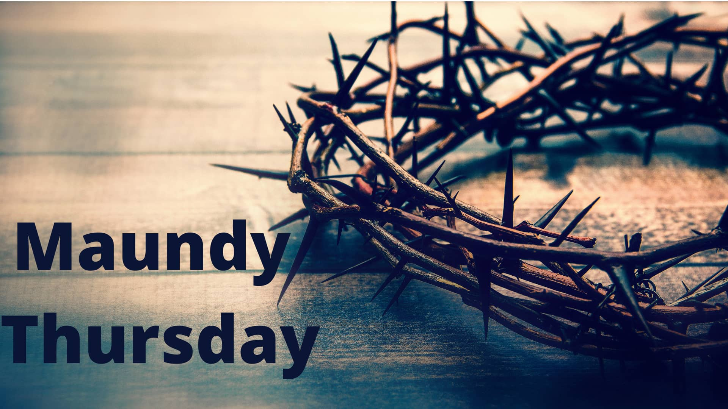

**Join us Sunday May 4 @ 1:30 for a concert put on by our band**



**Consider sponsoring the bulletin, hospitality, music or PowerZone for a special occasion or “just because”.**



***Upcoming Events at First Lutheran Church***

**April 15– Digging Into the Word. 10:00 – 11:30 @ the church office**

**April 16 – Confirmation class for youth. 6:30 – 8:30 @ church office & Sanctuary**

**April 17 – Maundy Thursday service @ 7:00pm**

**April 18 – Good Friday service @ 11:00am**

**April 22– Digging Into the Word. 10:00 – 11:30 @ the church office**

**April 23 – Confirmation class for youth. 6:30 – 8:30 @ church office & Sanctuary**

**April 27 – Pub Night @ Dorset 5:30 – 7:00**

**#**

**April’s hospitality has not been sponsored**



**April’s PowerZone has not been sponsored**



**April’s**

**bulletin has been sponsored Okite**



**April’s music has been sponsored**

**Eileen & Mark in celebration of their birthdays.**



**First Lutheran’s Vision Statement.**

**First Lutheran Church is a dynamic**

**Christian community that is making faith matter**

**in a constantly changing world.**

Facebook.com/FirstLutheranChurchCalgary

@FLCCalgary

Youtube.com/FirstLuthCalgary

FLCCalgary

**Visit us online at www.makingfaithmatter.ca**

**Want to contact us?**

**Office Hours: Monday – Wednesday, 10am-3pm**

**Office Phone 403-242-4544**

**Phil –** Pastor: Local 206 Cell number: 403-813-6797

[**phil@makingfaithmatter.ca**](mailto:phil@makingfaithmatter.ca)

**Kelly** – Financial Assistant & Property Manager:Local 207

Christmas Eve Candlelight Services

December 24th

at 3, 5 and 7pm.

Communion will

be served at all

three services.

All are welcome.

[**kelly@makingfaithmatter.ca**](mailto:kelly@makingfaithmatter.ca)

Worship for Palm/Passion Sunday

April 13, 2025

First Lutheran Church

*Palm/Passion Sunday*



**Yvonne –** Worship Director: Local 202

[**worship@makingfaithmatter.ca**](mailto:worship@makingfaithmatter.ca)

**Council –** Council Members

[**council@makingfaithmatter.ca**](mailto:council@makingfaithmatter.ca)

**Prayer –** SundayPrayer & Prayer Chain

[**prayer@makingfaithmatter.ca**](mailto:prayer@makingfaithmatter.ca)

**First Lutheran Church**

**7102 – 14th Avenue SW**

**Calgary, Alberta T3H 4G7**

**Tel: 403-242-4544**

**Journeying with God**

